EURUS 2026–2027 | C&C Recruitment

Task 1: Measure, Monitor, Act, Display
Scenario summary: An Arduino UNO measures a 0–12 V input and reads an MQ2 gas sensor. A buzzer and DC motor activate if the voltage reaches 8 V, the gas reading reaches the chosen threshold, or the user triggers the alarm manually through a MATLAB App Designer GUI.

System Overview
The system is designed to monitor voltage and gas levels using an Arduino UNO and activate an alarm when a dangerous condition is detected. The Arduino reads a voltage input ranging from 0–12 V through a potential divider and monitors gas concentration using an MQ2 gas sensor. If the input voltage reaches 8 V or the gas reading exceeds the defined threshold, the Arduino activates a buzzer and a DC motor. A MATLAB App Designer GUI communicates with the Arduino through a wired connection, allowing the user to monitor sensor readings and manually trigger the alarm when needed.
.

Part 1 — Theory

1.1 Analogue-to-Digital Converters (ADCs)

An Analog-to-Digital Converter (ADC) is a crucial electronic component that transforms continuous analog signals which represent real-world physical quantities like temperature, pressure, or sound—into discrete digital values.
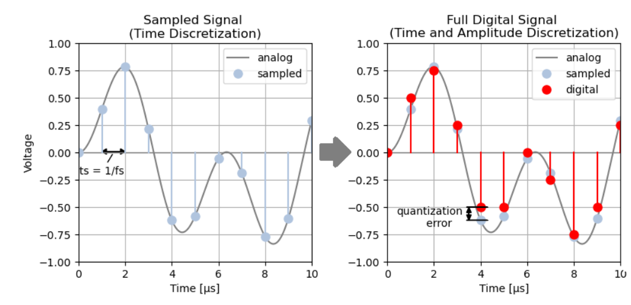

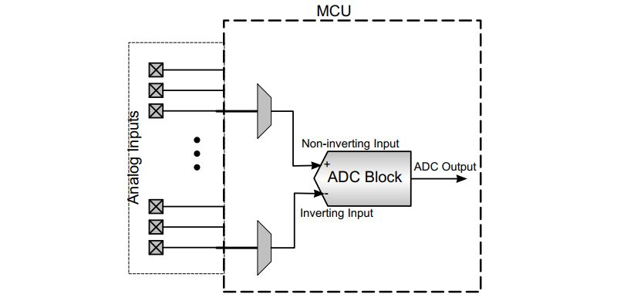
1.2 Arduino UNO ADC Specifications

An Arduino UNO, for example, contains a multichannel, 10-bit analog to digital converter (ADC). This means that it will map input voltages between 0 and the operating voltage (+5 VDC) into integer values between 0 and 1023. This yields a resolution between readings of: 5 volts / 1024 units or 0.0049 volts (4.9 mV) per unit.

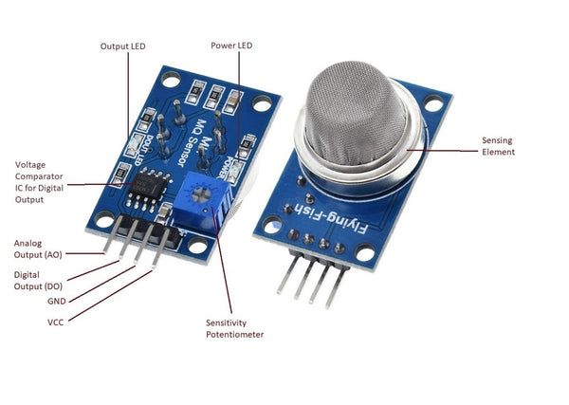
1.3 MQ2 Gas Sensor — Working Principle
MQ2 gas sensor is an electronic sensor used for sensing the concentration of gases in the air such as LPG, propane, methane, hydrogen, alcohol, smoke and carbon monoxide.
The sensor works as a chemiresistor, meaning that its electrical resistance changes when it is exposed to certain gases. It contains a sensing element made mainly of tin dioxide (SnO₂), along with a built-in heater that keeps the element at its operating temperature.
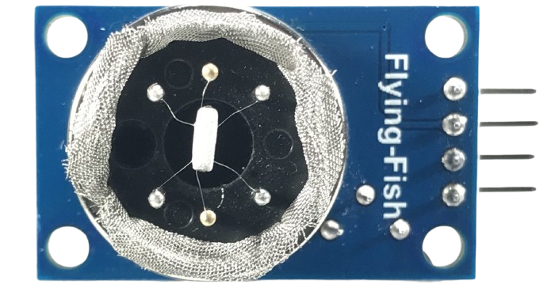
When the sensor is heated, oxygen from the air interacts with the surface of the tin dioxide, increasing its resistance. When reducing gases come into contact with the surface, they react with the adsorbed oxygen and cause the resistance to decrease.
This change in resistance produces a change in the sensor's output voltage. The Arduino reads this voltage through an analogue input pin and uses the reading to determine whether the gas level has reached the selected alarm threshold.
Additional Reference: For a more detailed explanation of the sensor's internal structure and working principle, see this video.

1.4 Potential Divider
The Arduino UNO analogue input cannot directly measure a voltage as high as 12 V, so a potential divider is used to reduce the input voltage to a safe level for the Arduino. The divider consists of two resistors connected in series, with the output voltage taken from the point between them.
The output voltage can be calculated using:
$$V_{out}=V_{in}\frac{R_{2}}{R_{1}+R_{2}}$$For this system, the resistor values are selected as R1=15k and R2=10k. This makes the output voltage 40% of the input voltage. When the input voltage is 12 V, the output voltage is 4.8 V, which is within the Arduino UNO's 5 V ADC input range. At the 8 V alarm threshold, the output voltage is 3.2 V.
The original input voltage can then be calculated from the measured output voltage using the divider ratio:

Part 2 — Simulation

2.1 Circuit Design

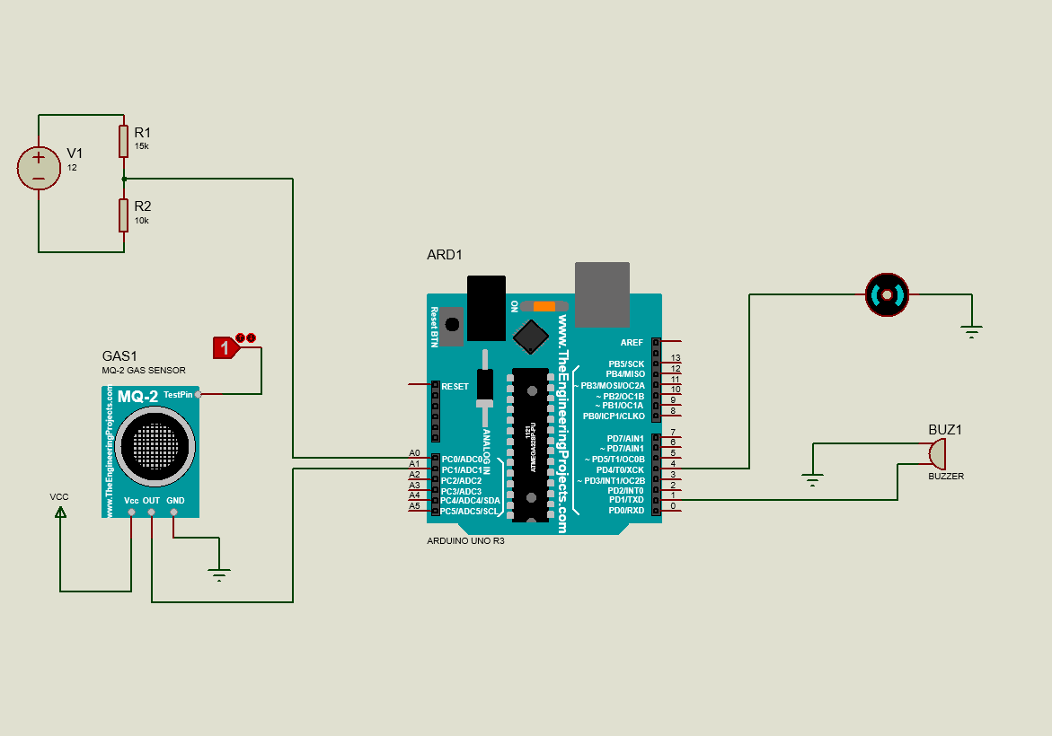

2.2 Control Logic
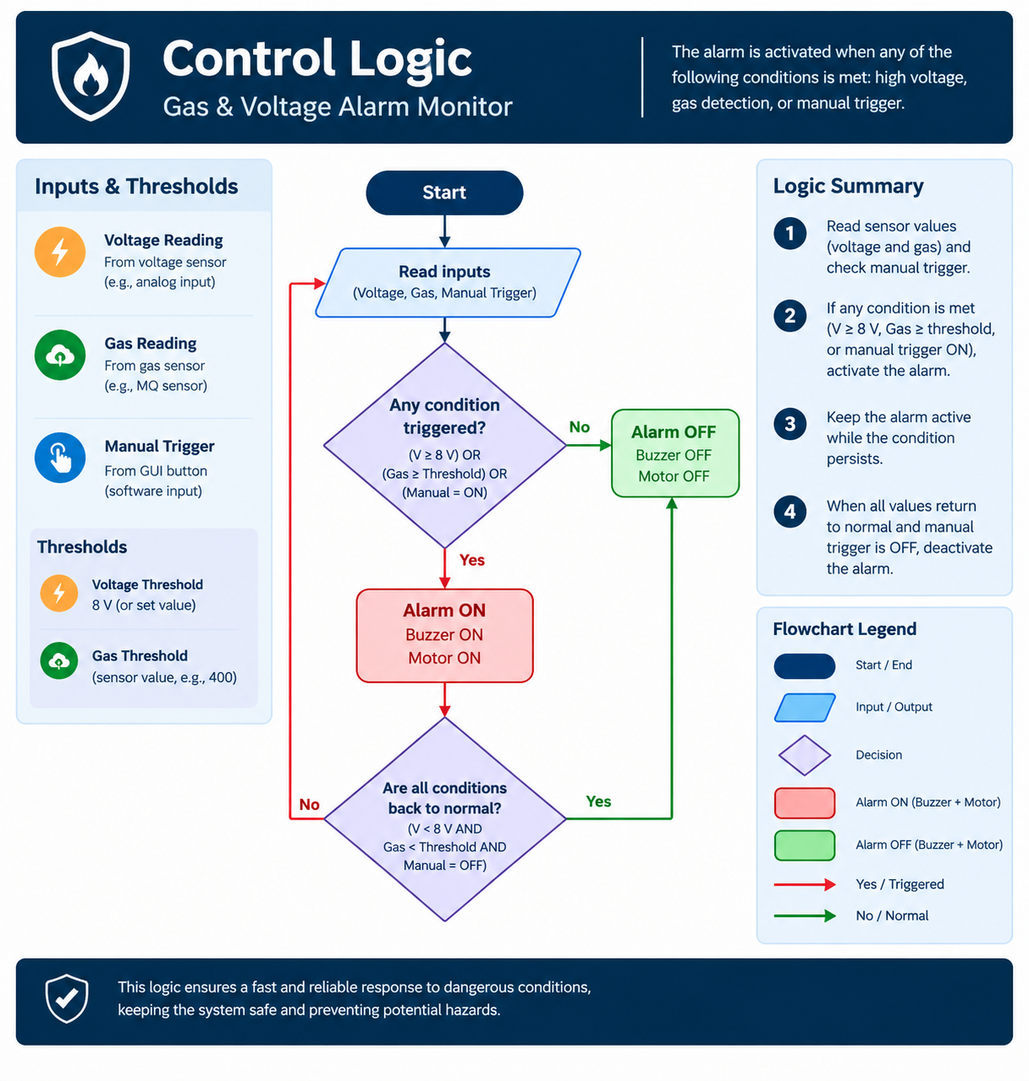
The alarm is activated when the input voltage reaches or exceeds 8 V, when the gas sensor detects gas above the selected threshold, or when the manual trigger is activated from the GUI. When any of these conditions occurs, the buzzer and DC motor are activated. The alarm remains active while at least one triggering condition is present. It is deactivated when the voltage and gas readings return to their normal ranges and the manual trigger is switched off.

2.3 Simulation Results

Test case | Input/condition | Expected result | Observed result
Normal condition | [Voltage below 8 V; gas below threshold] | Alarm OFF; buzzer and motor OFF | Alarm OFF; buzzer and motor OFF
Voltage trigger | [Voltage reaches/exceeds 8 V] | Alarm ON; buzzer and motor ON | Alarm ON; buzzer and motor ON
Gas trigger | [Gas reading reaches selected threshold] | Alarm ON; buzzer and motor ON | Alarm ON; buzzer and motor ON
Manual trigger | [GUI/manual command] | Alarm ON; buzzer and motor ON | Alarm ON; buzzer and motor ON

Part 3 — MATLAB App Designer GUI

3.1 GUI Design and Logic
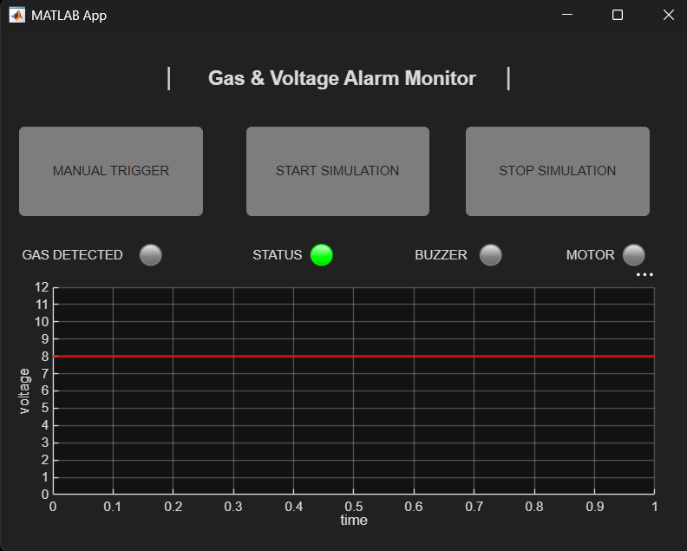
The MATLAB App Designer GUI was developed to monitor the input voltage, gas detection status, and alarm outputs. It displays the voltage variation over time, with a red reference line at 8 V to indicate the voltage alarm threshold. The interface also includes status indicators for gas detection, the overall system status, the buzzer, and the motor.
The control logic is organized using a state machine approach, in which the system changes its state according to the current input conditions and user commands. Four main states are used:
- Idle State: The system is in its normal condition, with the overall status indicating no active alarm and the buzzer and motor inactive.
- Voltage Trigger State: This state is entered when the input voltage exceeds 8 V. The system status changes to an alarm condition, and the buzzer and motor indicators turn on.
- Gas Trigger State: This state is intended to activate when the gas reading exceeds the selected threshold. The system status changes to an alarm condition, and the buzzer and motor indicators turn on.
- Manual Trigger State: The user can activate the alarm using the Manual Trigger button. Pressing the button again switches the manual override off.
The Start Simulation button generates simulated voltage and gas readings scripts and updates the graph and status indicators. The Stop Simulation button stops the simulation loop.
This state-based structure separates the system's operating conditions into distinct functions, making the control logic easier to understand, test, and modify.

3.3 Demonstration

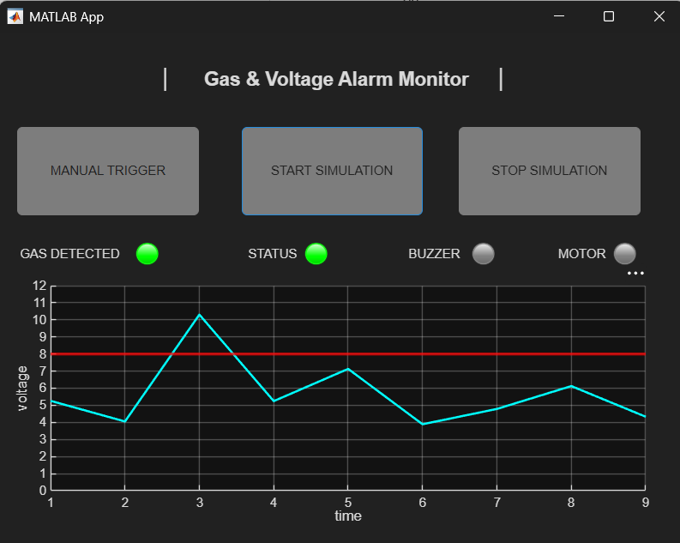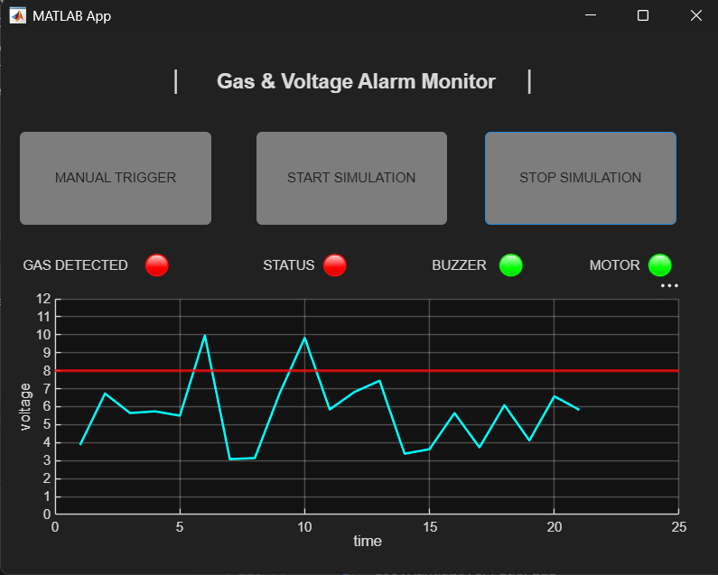
Pic (7): Idel state. Pic (8): Gas trigger state.

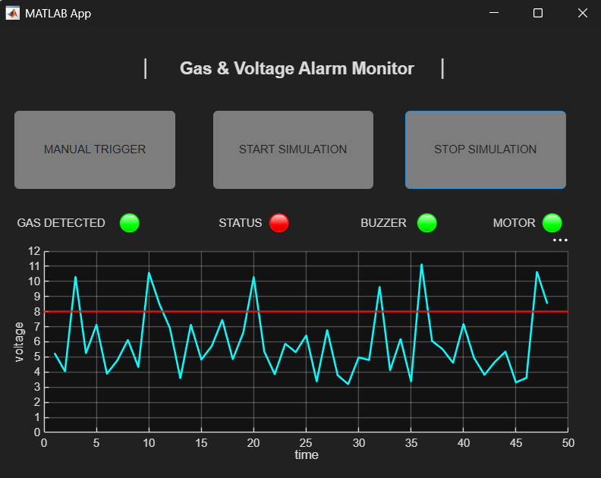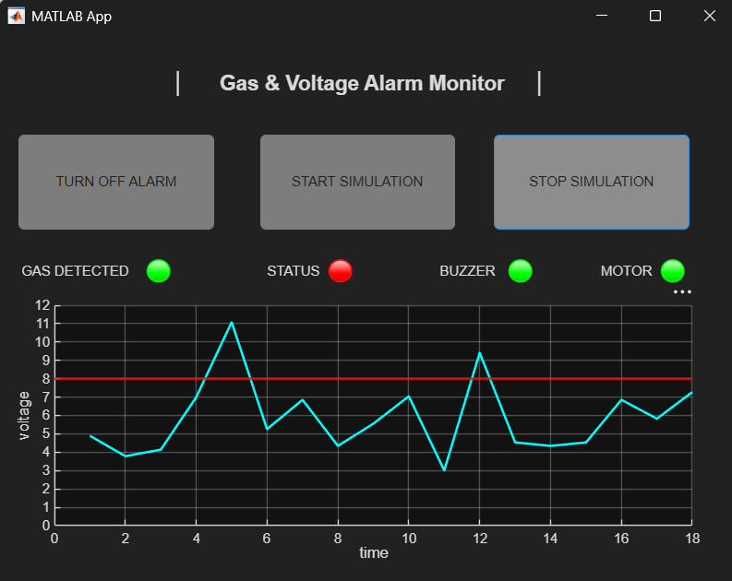
Pic (9): Voltage trigger state. Pic (10): Manual trigger state.

References
- (2024). Arduino.Cc. https://docs.arduino.cc/language-reference/en/functions/analog-io/analogRead/
- Blue Butterfly. (2025, May 7). How MQ2 gas sensor works ? | 3D animated [Video]. YouTube. https://www.youtube.com/watch?v=SqONrFwa4PA
- Elprocus. (2019, August 12). MQ2 gas sensor - working principle & its applications. ElProCus - Electronic Projects for Engineering Students. https://www.elprocus.com/an-introduction-to-mq2-gas-sensor/
- Kuphaldt, T. R. (2015, February 9). Voltage divider circuits. All About Circuits. Allaboutcircuit. https://www.allaboutcircuits.com/textbook/direct-current/chpt-6/voltage-divider-circuits/
- Develop apps using app designer - MATLAB & Simulink. (n.d.). Www.Mathworks.Com. Retrieved October 10, 2026, from https://www.mathworks.com/help/matlab/app-designer.html

